https://blog.csdn.net/myNameIssls/article/details/50829182?locationNum=15

**Caused by: java.lang.ClassNotFoundException: org.aspectj.util.PartialOrder$PartialComparable**

2016年03月08日 17:51:07 [小曦阳哟](https://me.csdn.net/myNameIssls) 阅读数：6345

版权声明：本文为博主原创文章，未经博主允许不得转载。 https://blog.csdn.net/myNameIssls/article/details/50829182

问题描述：

在SpringMVC配置AOP代理【<aop:config proxy-target-class="true"></aop:config>】时，报如下错误：

org.springframework.beans.factory.BeanCreationException: Error creating bean with name 'loginController' defined in file [D:\JavaEEServers\Tomcat\apache-tomcat-7.0.42\webapps\tyrone-shiro\WEB-INF\classes\cn\tyrone\shiro\controller\LoginController.class]: Initialization of bean failed; nested exception is java.lang.NoClassDefFoundError: org/aspectj/util/PartialOrder$PartialComparable  
at org.springframework.beans.factory.support.AbstractAutowireCapableBeanFactory.doCreateBean(AbstractAutowireCapableBeanFactory.java:553)  
at org.springframework.beans.factory.support.AbstractAutowireCapableBeanFactory.createBean(AbstractAutowireCapableBeanFactory.java:482)  
at org.springframework.beans.factory.support.AbstractBeanFactory$1.getObject(AbstractBeanFactory.java:306)  
at org.springframework.beans.factory.support.DefaultSingletonBeanRegistry.getSingleton(DefaultSingletonBeanRegistry.java:230)  
at org.springframework.beans.factory.support.AbstractBeanFactory.doGetBean(AbstractBeanFactory.java:302)  
at org.springframework.beans.factory.support.AbstractBeanFactory.getBean(AbstractBeanFactory.java:197)  
at org.springframework.beans.factory.support.DefaultListableBeanFactory.preInstantiateSingletons(DefaultListableBeanFactory.java:772)  
at org.springframework.context.support.AbstractApplicationContext.finishBeanFactoryInitialization(AbstractApplicationContext.java:839)  
at org.springframework.context.support.AbstractApplicationContext.refresh(AbstractApplicationContext.java:538)  
at org.springframework.web.context.ContextLoader.configureAndRefreshWebApplicationContext(ContextLoader.java:446)  
at org.springframework.web.context.ContextLoader.initWebApplicationContext(ContextLoader.java:328)  
at org.springframework.web.context.ContextLoaderListener.contextInitialized(ContextLoaderListener.java:107)  
at org.apache.catalina.core.StandardContext.listenerStart(StandardContext.java:4939)  
at org.apache.catalina.core.StandardContext.startInternal(StandardContext.java:5434)  
at org.apache.catalina.util.LifecycleBase.start(LifecycleBase.java:150)  
at org.apache.catalina.core.ContainerBase$StartChild.call(ContainerBase.java:1559)  
at org.apache.catalina.core.ContainerBase$StartChild.call(ContainerBase.java:1549)  
at java.util.concurrent.FutureTask$Sync.innerRun(FutureTask.java:303)  
at java.util.concurrent.FutureTask.run(FutureTask.java:138)  
at java.util.concurrent.ThreadPoolExecutor$Worker.runTask(ThreadPoolExecutor.java:895)  
at java.util.concurrent.ThreadPoolExecutor$Worker.run(ThreadPoolExecutor.java:918)  
at java.lang.Thread.run(Thread.java:662)  
Caused by: java.lang.NoClassDefFoundError: org/aspectj/util/PartialOrder$PartialComparable  
at java.lang.ClassLoader.defineClass1(Native Method)  
at java.lang.ClassLoader.defineClassCond(ClassLoader.java:631)  
at java.lang.ClassLoader.defineClass(ClassLoader.java:615)  
at java.security.SecureClassLoader.defineClass(SecureClassLoader.java:141)  
at org.apache.catalina.loader.WebappClassLoader.findClassInternal(WebappClassLoader.java:2895)  
at org.apache.catalina.loader.WebappClassLoader.findClass(WebappClassLoader.java:1173)  
at org.apache.catalina.loader.WebappClassLoader.loadClass(WebappClassLoader.java:1681)  
at org.apache.catalina.loader.WebappClassLoader.loadClass(WebappClassLoader.java:1559)  
at org.springframework.aop.aspectj.autoproxy.AspectJAwareAdvisorAutoProxyCreator.sortAdvisors(AspectJAwareAdvisorAutoProxyCreator.java:73)  
at org.springframework.aop.framework.autoproxy.AbstractAdvisorAutoProxyCreator.findEligibleAdvisors(AbstractAdvisorAutoProxyCreator.java:91)  
at org.springframework.aop.framework.autoproxy.AbstractAdvisorAutoProxyCreator.getAdvicesAndAdvisorsForBean(AbstractAdvisorAutoProxyCreator.java:69)  
at org.springframework.aop.framework.autoproxy.AbstractAutoProxyCreator.wrapIfNecessary(AbstractAutoProxyCreator.java:346)  
at org.springframework.aop.framework.autoproxy.AbstractAutoProxyCreator.postProcessAfterInitialization(AbstractAutoProxyCreator.java:298)  
at org.springframework.beans.factory.support.AbstractAutowireCapableBeanFactory.applyBeanPostProcessorsAfterInitialization(AbstractAutowireCapableBeanFactory.java:422)  
at org.springframework.beans.factory.support.AbstractAutowireCapableBeanFactory.initializeBean(AbstractAutowireCapableBeanFactory.java:1583)  
at org.springframework.beans.factory.support.AbstractAutowireCapableBeanFactory.doCreateBean(AbstractAutowireCapableBeanFactory.java:545)  
... 21 more  
Caused by: java.lang.ClassNotFoundException: org.aspectj.util.PartialOrder$PartialComparable  
at org.apache.catalina.loader.WebappClassLoader.loadClass(WebappClassLoader.java:1714)  
at org.apache.catalina.loader.WebappClassLoader.loadClass(WebappClassLoader.java:1559)  
... 37 more

如下图：

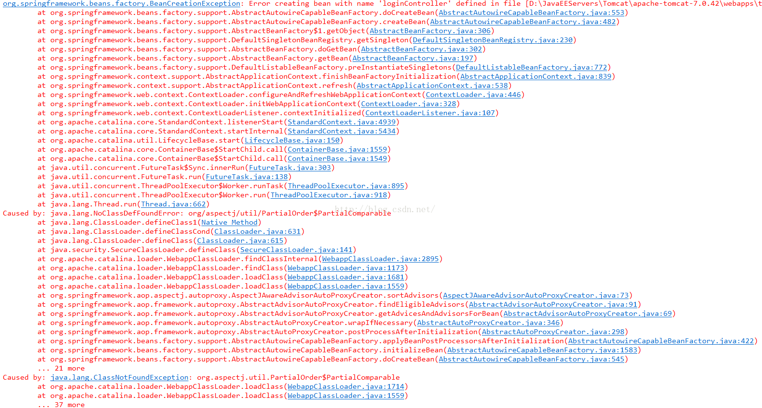

解决方案：

经检查，是因为缺少aspectjweaver的jar文件，pom文件中加入该依赖即可解决。

pom坐标如下：

<dependency>  
<groupId>org.aspectj</groupId>  
<artifactId>aspectjweaver</artifactId>  
<version>1.8.8</version>  
</dependency>